**1.3.4:**

**Does your university as a body have programmers or initiatives to assist students who fall into the bottom 20% of household income group (or a more tightly defined target) in the country to successfully complete their studies?**

**A N S W E R:**

**Alkafeel University Support for Underrepresented Groups (2023)**

Alkafeel University continues its dedicated support for underrepresented groups, ensuring equal educational opportunities through a range of financial, academic, and health services. In the past year, the university has strengthened its initiatives, targeting students from the bottom 20% of household income, as well as other marginalized groups.

#### Financial Support

In 2023, Alkafeel provided scholarships and fee reductions to 299 students from various disadvantaged backgrounds, including orphans, victims of terror acts, low-income families, displaced individuals, minorities, and students with disabilities. The total financial aid granted amounted to **1.05 billion IQD**, showing a steady increase from the previous year, with 20% reductions for specific cases and free or half scholarships for others.

**this is a list of the number of students who received a free scholarship:**

|  |  |  |
| --- | --- | --- |
| **Department** | **Male** | **female** |
| Human Medicine | 24 | 15 |
| Pharmacy | 43 | 75 |
| Dentistry | 47 | 95 |

#### Academic and Health Support

To ensure these students thrive academically and socially, Alkafeel University provides:

* 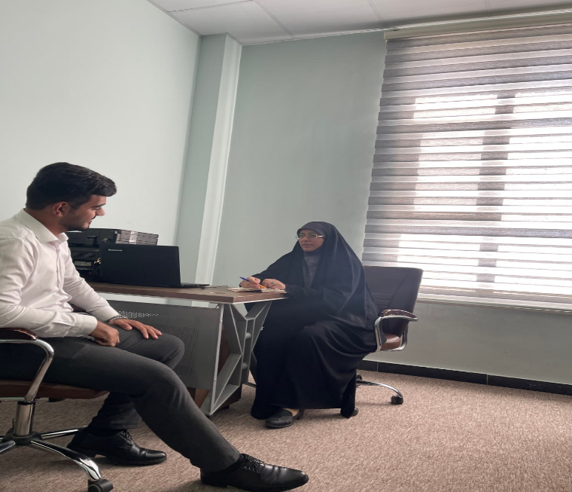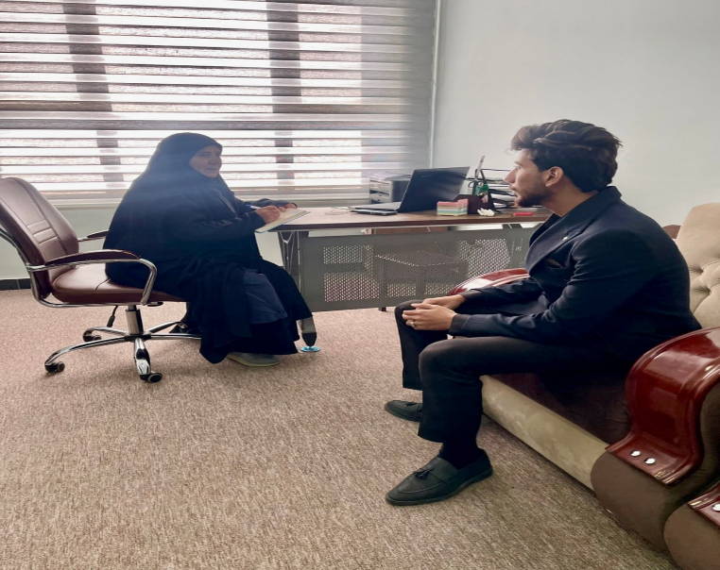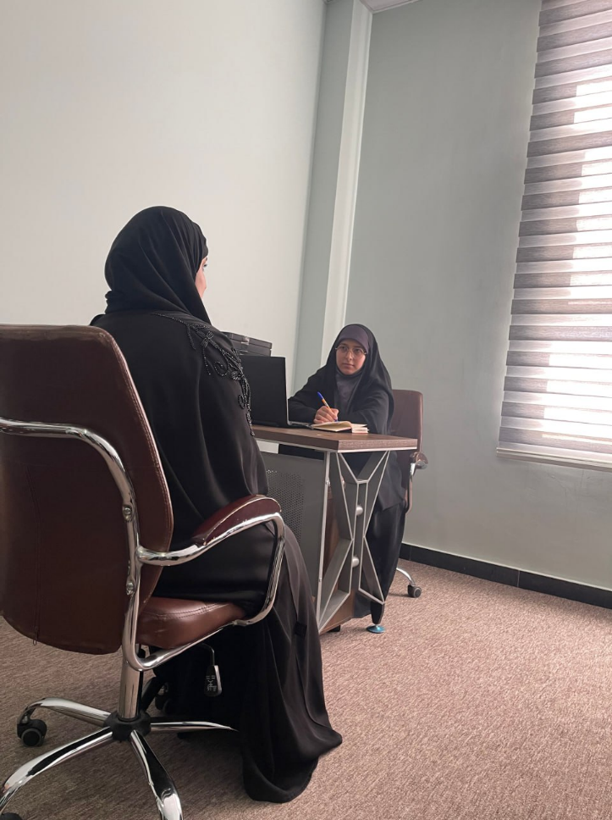**Personalized Academic Support**: Students receive one-on-one mentoring and tutoring services to help them succeed academically.

Below are some of guiding unit activates

|  |  |
| --- | --- |
| Pic | University order |
|  | **Community service activity**  Based on the authority granted to us in accordance with Law No. 25 of 2016, we have decided to conduct a community service activity to visit children suffering from leukemia at the Cancer and Tumor Center to provide financial support for these categories. The visit is scheduled for Wednesday, 29/11/2023, at 10:00 AM, with participation from the teaching staff and students of the College of Medicine, second-year students listed in the attached list. |
|  | **Student trip**  Based on the authority granted to us in accordance with Law No. 25 of 2016, we have decided to organize a trip to the Holy Shrines in Karbala for third-year students of the College of Pharmacy, whose names are listed in the attached list. This is to participate in some activities to promote moral values, accompanied by their academic advisors. The trip will take place on Wednesday, 29/11/2023.  1. Dr. Hussam Ali Hassan Al-Ubaidi  2. Mrs. Hanaa Nouri Ahmed  3. Mr. Mohamed Jabbar Obeid |
|  | **Student trip**  Based on the authority granted to us in accordance with Law No. 25 of 2016, we have decided to organize a recreational trip to the city of Nuwaira, the tourist destination in Karbala, for third- and fourth-year students of the College of Health and Medical Technologies / Department of Laboratory Analysis. The trip will take place on Friday, 1/12/2023, accompanied by teachers and academic advisors. |
|  | **Visit**  Based on the authority granted to us in accordance with Law No. 25 of 2016, we have decided to organize a visit to the "Hakayati" Center and provide both financial and moral support for orphans. The visit will be accompanied by a group of teaching staff and some students from the College of Health and Medical Technologies. This will take place on Tuesday, 26/12/2023. |
|  | **Student trip**  Based on the authority granted to us in accordance with Law No. 25 of 2016, we have decided to organize a recreational trip to the city of Nuwaira, the tourist destination in Karbala, for the students of the College of Health and Medical Technologies / Department of Radiology and Anesthesia. The trip will take place on Thursday, 14/12/2023, accompanied by teachers and academic advisors. |
|  | **Student trip**  Based on the authority granted to us in accordance with Law No. 25 of 2016, we have decided to organize a recreational trip to the city of Nuwaira, the tourist destination in Karbala, for the students of the College of Dentistry. The trip will take place on Thursday, 7/12/2023, accompanied by teachers and academic advisors. |
|  | **Seminar**  Based on the authority granted to us in accordance with Law No. 25 of 2016 (as amended), we have decided to hold a symposium on Quranic recitation in collaboration with the Holy Quran Institute in Najaf - The Scientific Society for the Holy Quran / The Holy Al-Abass Shrine. The symposium is titled "The Quranic Vision in the Importance of Veil and Modesty and Its Reflection in the Blessed Biography of Lady Zainab Al-Kubra (Peace Be Upon Her)" and will be held with the honorable guest Sheikh Zaman Sahib Mahdi on the occasion of the blessed birth anniversary of Lady Zainab (Peace Be Upon Her). The symposium will take place in the building of the College of Medicine at 10:00 AM on Monday, 20/11/2023. |
|  | **Forum**  Based on the authority granted to us in accordance with Law No. 25 of 2016 (as amended), we have decided to organize a session for memorization, recitation, and study of the Holy Quran for female students every Monday of each week throughout the academic year 2023-2024, during free student hours. This will be in cooperation with the Holy Quran Institute in Najaf - The Scientific Society for the Holy Quran / The Holy Al-Abass Shrine. |
|  | **Training forums**  Based on the authority granted to us in accordance with Law No. 25 of 2016 (as amended), we have decided to organize training forums for the development of the capabilities and skills of our students during free hours, according to the academic schedules of the colleges and scientific departments, for the academic year 2023-2024. This will be with the participation of the advanced coach Mr. Safaa Muhammad Jawad. |
|  | **Forum**  Based on the authority granted to us in accordance with Law No. 25 of 2016 (as amended), we have decided to organize a student drawing forum every Monday and Wednesday of each week during the academic year 2023-2024, during free student hours, with the participation of instructor Dr. Bahaa Swadi from the Department of Art Education at the College of Mixed Education, the University of Kufa. |
|  | **Community service**  Based on the authority granted to us in accordance with Law No. 25 of 2016 (as amended), we have decided to organize a community service campaign by hosting a group of orphans (35 children) in coordination with the `Aein Foundation for Social Care, to attend a ceremony at our university on the occasion of the Prophet’s Birthday on Tuesday, 3/10/2023, at 10:00 AM. The event will include providing them with a meal and some gifts, with participation from teachers, staff, and academic advisors, whose names are listed in the attached list. |
|  | **Ceremony**  Based on the authority granted to us in accordance with Law No. 25 of 2016 (as amended), we have decided to hold a ceremony on the occasion of the Prophet’s Birthday on Tuesday, 3/10/2021, at 10:00 AM, according to the program outlined in the attached schedule. |
|  | **Ceremony**  Based on the authority granted to us in accordance with Law No. 25 of 2016, we have decided to hold a ceremony to celebrate the birth of Lady Fatima Al-Zahra (peace be upon her) on Wednesday, 20th of Jumada al-Akhira, 1445 AH, corresponding to 3/1/2024. The event will also include an exhibition of artistic and handcrafted works for students. |

* 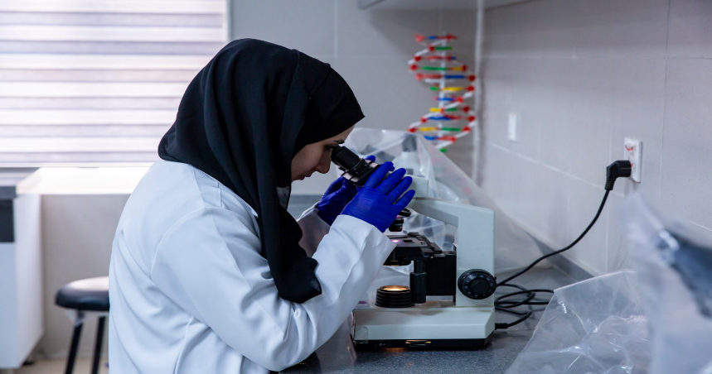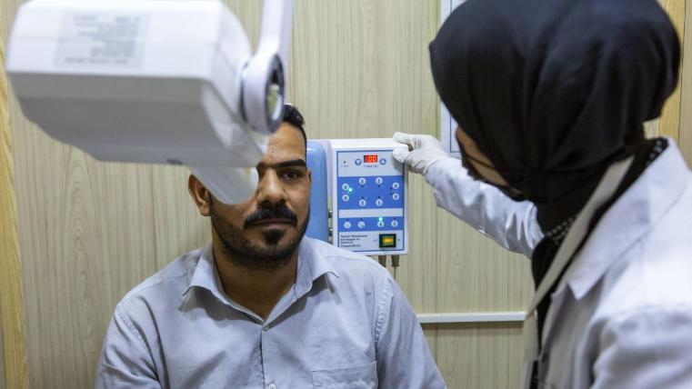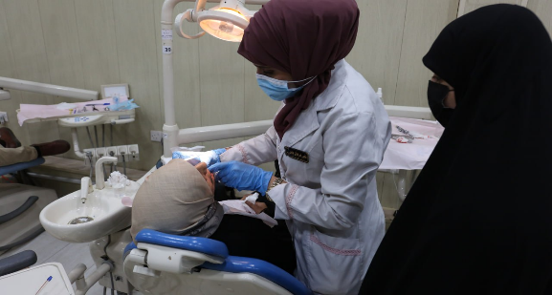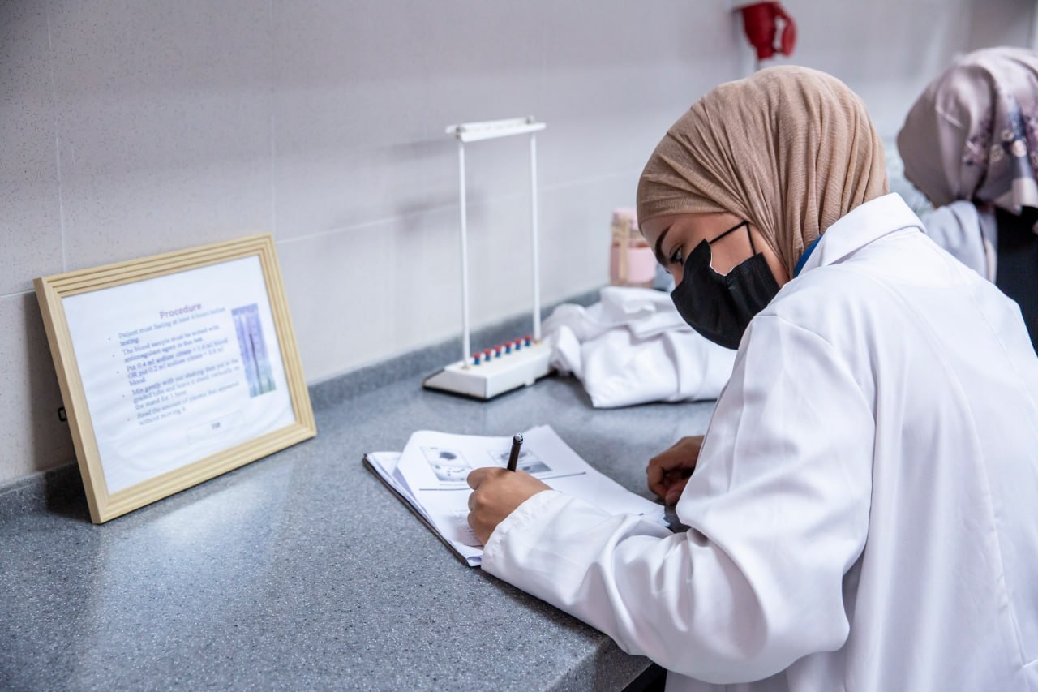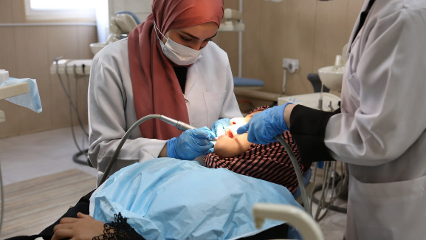**Health Services**: "Health Comes to You" is a university-led initiative where medical assistance and health counseling are provided to students in need, especially those who are sick or cannot easily access external healthcare facilities.

**Medical care**

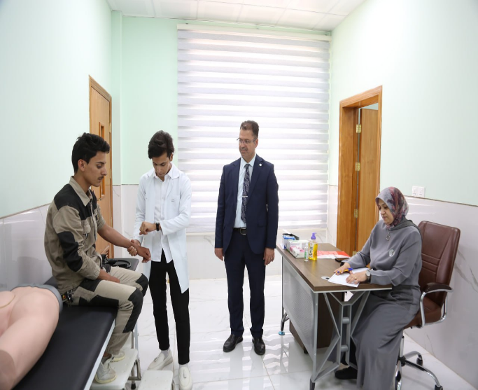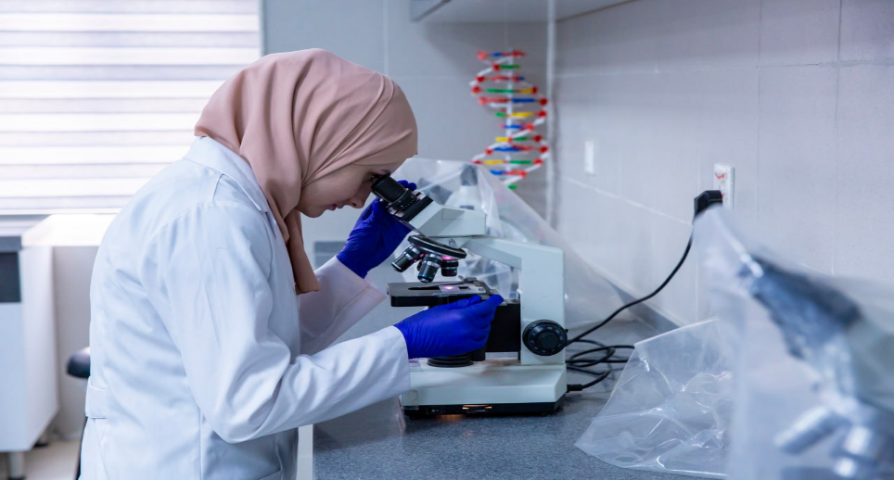

**Medical care**